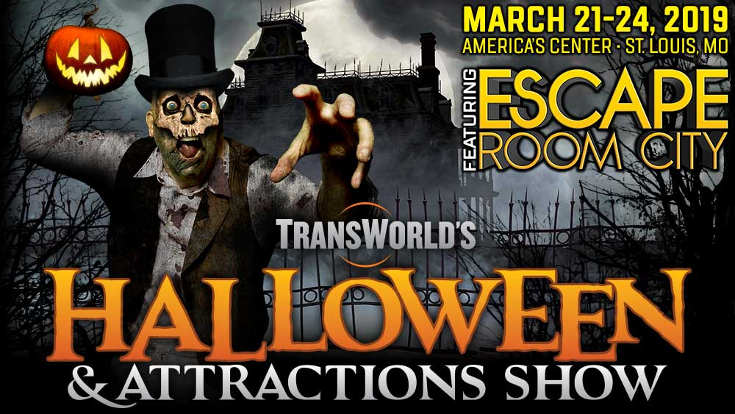

Hello, NAME -
As a customer of YOUR COMPANY NAME, I'd like to invite you to be my guest at TransWorld's 2019 Halloween & Attractions Show in St. Louis, March 21-24, as they celebrate 36 years of in the haunted attraction & Halloween industry!
The Halloween & Attractions Show is a business-to-business trade show that isn't open to the general public, and attendees are typically required to provide certain credentials before being permitted to register. However, because you're one of my customers, you don't have to do that! Instead, please fill out and submit THIS FORM, you may proceed directly to registration to purchase tickets for the show!
I look forward to seeing you at Booth (YOUR BOOTH NUMBER)!
YOUR NAME
YOUR COMPANY NAME
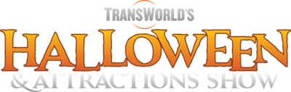
Once you've verified yourself with Rich Bianco (see above), you can register and get additional information at http://www.HAASHOW.com

